GraphQL API

🔹 What is a GraphQL API?
# Source: AI Source: Provided by: [Data Path: Persons Table -> ID Column: 1, Name_En Column: Motasem Essam] -> From: [Chatgpt (GPT‑5 Mini)] on [1/19/2026]
A GraphQL API is a modern alternative to REST and SOAP APIs, developed by Facebook. It allows clients to request exactly the data they need, and nothing more — making data fetching more efficient, flexible, and powerful.

✅ Key Features of GraphQL:
# Source: AI Source: Provided by: [Data Path: Persons Table -> ID Column: 1, Name_En Column: Motasem Essam] -> From: [Chatgpt (GPT‑5 Mini)] on [1/19/2026]
Feature | Description
Single Endpoint | Unlike REST (multiple URLs), GraphQL uses one endpoint for all queries.
Flexible Queries | Clients can specify exactly what fields they want in the response.
Real-Time Support | Supports subscriptions for real-time data (like chat or notifications).
Strong Typing | Uses a schema that defines the types and structure of data.
Efficient Data Fetching | Prevents over-fetching and under-fetching of data.

🔍 Example: Requesting Data with GraphQL

🎯 Client Request:
# Source: AI Source: Provided by: [Data Path: Persons Table -> ID Column: 1, Name_En Column: Motasem Essam] -> From: [Chatgpt (GPT‑5 Mini)] on [1/19/2026]
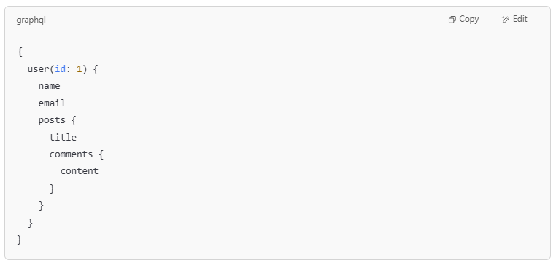
{
user(id: 1) {
name
email
posts {
title
comments {
content
}
}
}
}

📦 Server Response (JSON):
# Source: AI Source: Provided by: [Data Path: Persons Table -> ID Column: 1, Name_En Column: Motasem Essam] -> From: [Chatgpt (GPT‑5 Mini)] on [1/19/2026]
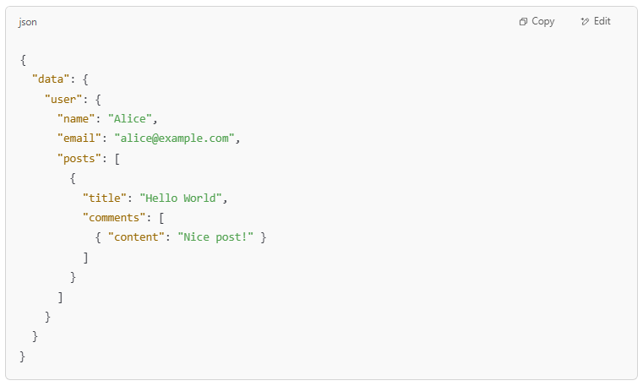
{
"data": {
"user": {
"name": "Alice",
"email": "alice@example.com",
"posts": [
{
"title": "Hello World",
"comments": [
{ "content": "Nice post!" }
]
}
]
}
}
}

Only the requested data is returned — no more, no less.

🆚 GraphQL vs REST:
# Source: AI Source: Provided by: [Data Path: Persons Table -> ID Column: 1, Name_En Column: Motasem Essam] -> From: [Chatgpt (GPT‑5 Mini)] on [1/19/2026]
Feature | GraphQL | REST
Endpoints | Single /graphql endpoint | Multiple endpoints (/users, /posts)
Data Fetching | Client specifies exactly what it needs | Server defines fixed responses
Efficiency | High (fetch nested data in one call) | May require multiple requests
Learning Curve | Higher (custom query language) | Lower (uses HTTP methods)

🧠 In Summary:
# Source: AI Source: Provided by: [Data Path: Persons Table -> ID Column: 1, Name_En Column: Motasem Essam] -> From: [Chatgpt (GPT‑5 Mini)] on [1/19/2026]
A GraphQL API gives clients more control over the data they get, reduces unnecessary network traffic, and simplifies complex data fetching. It’s ideal for modern web and mobile applications.

